Terentius Nero and his wife

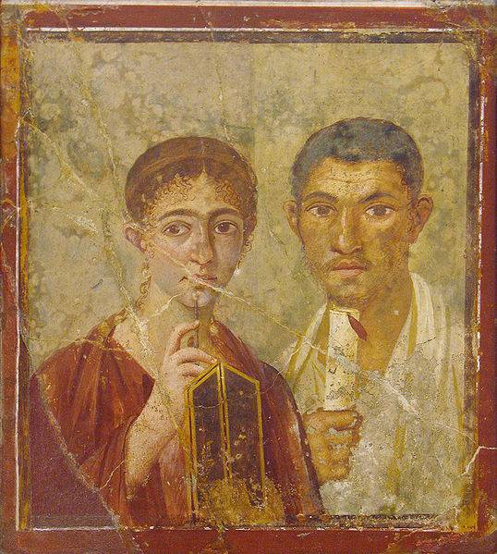
Original image source: http://commons.wikimedia.org/wiki/File:Terentius_Neo_e_la_Moglie.jpg

Terentius Nero and his wife

Some points of interest
- Size of the picture 58cm x 65cm.
- Originally situated as a small rectangular panel on the back wall of an exedra.
- Identification of couple is based on election slogans painted near entrance of house
- House belonged to T. Neo, a lawyer and T. Proculus, a baker.
- Presence of stylus and tablet is a common motif in portraiture in Pompeii (such as the ‘Sappho’)
- Style of portrait very similar to those found in Roman Egypt.
- Position of portrait on back wall of exedra means it would be visible to anyone going through hall.
- Hairstyle dates painting to last 25 years of Pompeii’s existence.

